Radiance(time, y_along_track, x_cross_track)

Should x be along track?

Map boxes to a 2 d array.

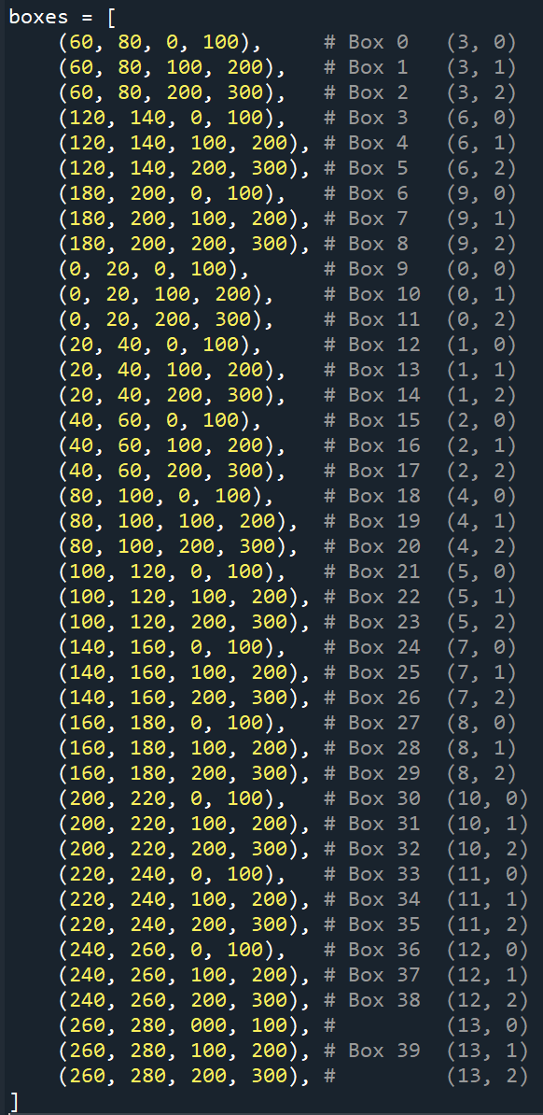

Create two new dimensions: y_box_along_track (size=3), and x_box_cross_track (size=14)

Add MLCloud variable (‘time’, ‘y_box_along_track’, ‘x_box_corss_track’)

Modify the visualization script accordingly.

I made modifications based on our discussion earlier today regarding the structure of ML information in the NetCDF files.

**What I did:**

* Verified that in the NetCDF file, the variable **Radiance** is saved as Radiance(time, y_along_track, x_cross_track).
* Mapped the boxes to a 2D array.
* Added two new dimensions: y_box_along_track (size=3) and x_box_cross_track (size=14).
* Included the MLCloud variable with dimensions (time, y_box_along_track, x_box_cross_track).
* Updated the visualization script accordingly.

The boxes in the NetCDF file are now organized in the format (x_box_cross_track, y_box_along_track) as shown in the attached figure.

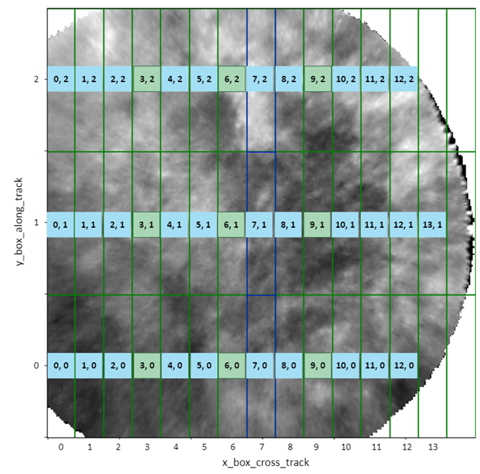

Dominique’s labelling:

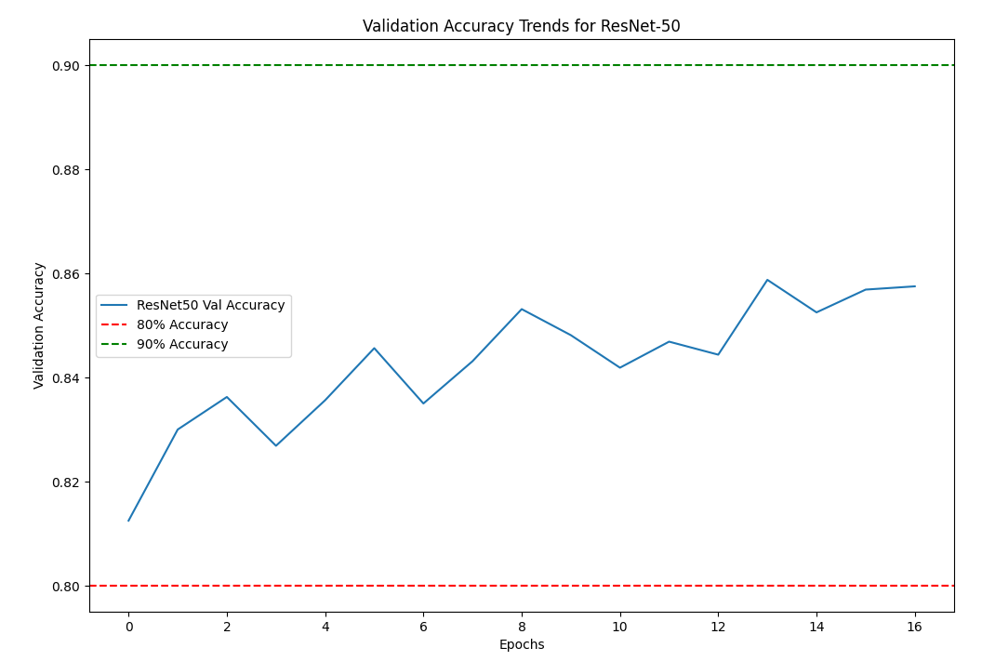

Expand the size of the boxes (40x100):

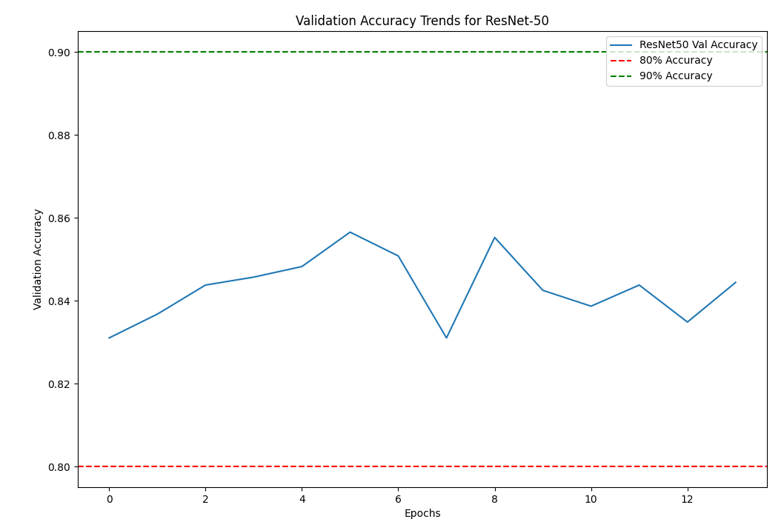

(30x100):

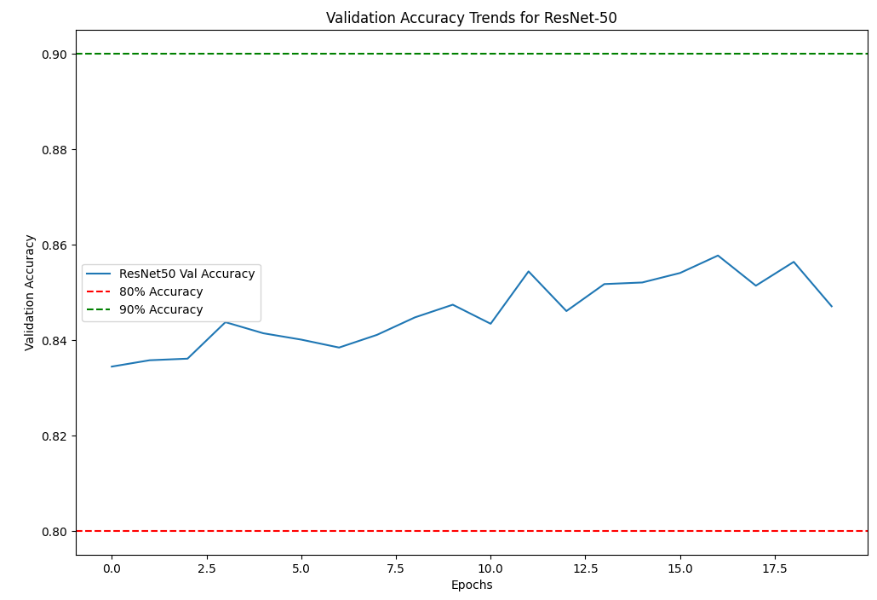

Before and after: 5 -> 3 frames

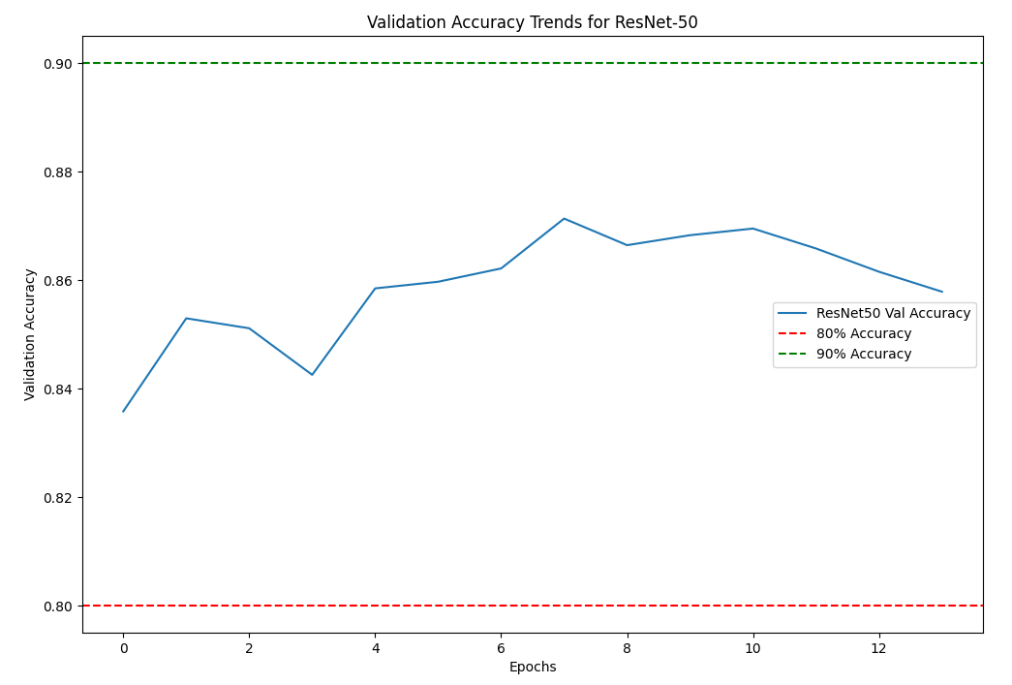

30x106, 3 frames

